Module 1 · Orient & Architect First
Exercise 1: First Contact: Orient Inside Claude Code
Dev cycle | Design (orientation)
CC features | /help, /status, /context, /model, /cost, plan mode (Shift+Tab), permission model
Spec traces | Reads docs/BRIEF.md (no code yet)
Time | 20 min
You produce | A working Claude Code session inside the DischargeFlow course repo, and a feel for the built-in commands

Objective
Before you write a line of DischargeFlow, get fluent in the cockpit. Claude Code is not a chat box: it runs in your terminal, reads and edits files on your machine, and runs commands. This exercise builds muscle memory for the built-in slash commands and the permission model, so you stay in control later when the stakes are higher: today's project handles (synthetic) patient data, and every habit you form here protects it.
Walk-through
1 | Confirm the CLI

Open VS Code, open a terminal (Terminal > New Terminal; PowerShell on Windows, zsh or bash on macOS), and confirm Claude Code is installed. Slash commands only work once you are inside a session, so first confirm the CLI itself.
Run in terminal
PS> claude --version
PS> claude doctor
VALIDATE claude --version prints a 2.1.x build. claude doctor reports your install, runtime and auth as healthy. If auth is missing, run claude auth login first.
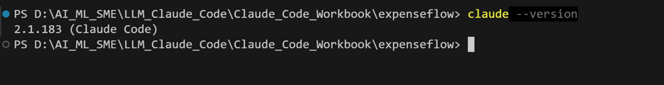
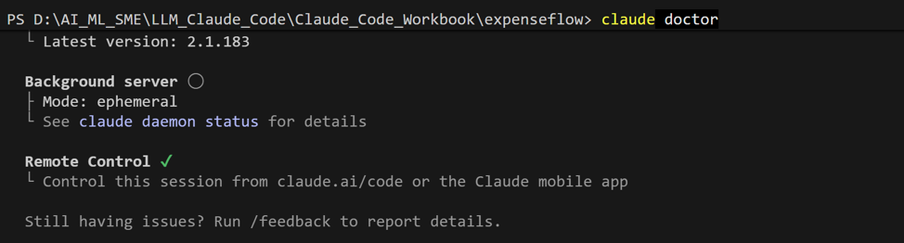
2 | Clone the course repo and start a session

The course repo is spec-first: it contains the brief, the specification, the safety policy and synthetic sample data, but no application code. You will build that. Clone it, open it in VS Code, and launch Claude Code from inside it.
Run in terminal
PS> git clone https://github.com/cellstratindra/claude_code_administrator_learning.git dischargeflow
PS> cd dischargeflow
PS> code .
PS> claude
Inside the Claude Code session
> /help
> /status
VALIDATE /help lists built-in commands plus any bundled skills. /status shows your model, the working directory (it must end in dischargeflow), and the permission mode.
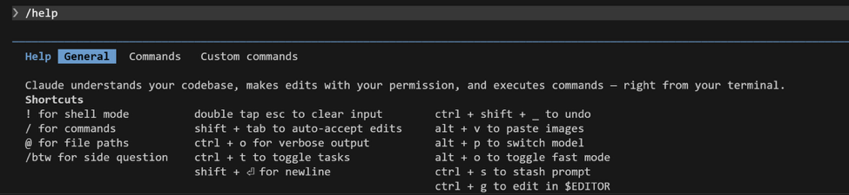
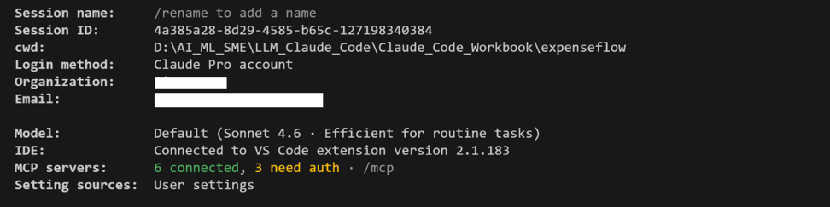
3 | Inspect your context and model

Two commands you will lean on all day. /context shows how much of the context window is in use, which is how you avoid quality drops on long builds. /model lets you pick the engine for the task.
Inside the Claude Code session
> /context
> /model
VALIDATE /context renders a usage map (system prompt, tools, memory files, messages). /model lists the available Opus, Sonnet and Haiku models and lets you switch. Leave it on the default for now.
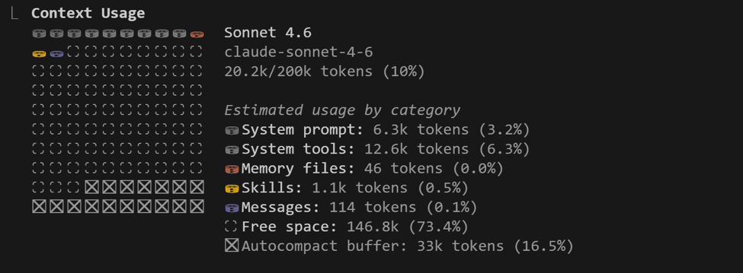
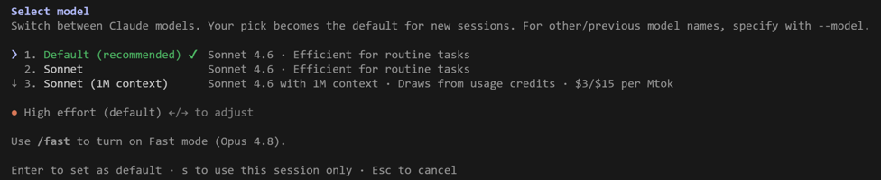
4 | Meet plan mode and the permission model

Press Shift+Tab to cycle the mode indicator at the bottom of the screen between normal, auto-accept edits, and plan mode. Plan mode lets Claude read and propose without touching files. Switch to plan mode, then give it a read-only task on the real project brief.
Type this prompt into Claude Code
Read docs/BRIEF.md and docs/POLICY.md. In five bullets, tell me what we are building today, who the users are, and the three rules that look most likely to be broken by careless AI-generated code. Do not create or edit any files.
VALIDATE In plan mode Claude reads the files and answers, but makes no edits. Expect it to call out the clinician sign-off, doses never being floats or model-written, and PHI masking. Now switch to normal mode and ask it to create a scratch file: it asks your permission first. That approval gate is your safety net; never disable it on day one.
SCREENSHOT SLOT Plan-mode answer summarising BRIEF.md in five bullets
5 | Check the meter

Cost awareness is a core practitioner habit. Run /cost to see token spend for the session so far.
Inside the Claude Code session
> /cost
VALIDATE /cost prints tokens and approximate spend for this session. You will return to it in Exercise 11 when you manage a long build.
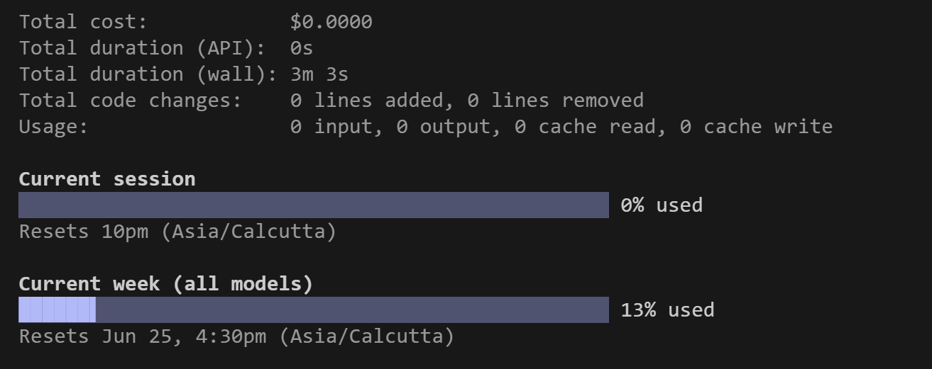
What success looks like
- You can enter and leave plan mode at will and explain the difference between plan, auto-accept, and normal mode.
- You can name what /help, /status, /context, /model, and /cost each do without looking them up.
- You can say in one sentence what DischargeFlow does and why a human reviewer signs every draft.
Common pitfalls (Windows and macOS)
- If claude is not recognised, your PATH was not refreshed: close and reopen the VS Code terminal after install.
- PowerShell may block scripts. If a command is refused, run Set-ExecutionPolicy -Scope Process -ExecutionPolicy Bypass for this session only.
- Slash commands do nothing in your normal shell: they only work after you have started a session with claude.
- Starting claude from the wrong folder means it cannot see the brief. /status shows the working directory; check it.
Go deeper · AI developer track
Optional, for faster finishers. Each challenge extends the lab with a production-grade technique.
- Run Claude Code headless: claude -p "List the top-level folders and what each is for" --output-format json. Inspect the JSON (result, turns, cost) and explain how print mode lets you use Claude Code in scripts and CI.
- Launch with claude --permission-mode plan and compare it with toggling Shift+Tab. When would you want a session that starts read-only by default?
Stretch goal
Type / and arrow through the entire menu. Find /resume (reopen a past session), /clear (wipe history) and /rewind (undo to a checkpoint), and read what each one warns about before you need them in anger.

